BizPulse
A Mobile Application for Small Business Management
In Partial Fulfillment of the Requirements for the Degree of Bachelor of Science in Information Systems
CT-MAD 213
Mobile Application Development
Submitted by
Team BIZPULSE • BSIS 2C
Jedediah Ebalobo
Irene Trinidad
Rochelyn Bacsal
Ralph Jayrhard Amor
Alexander Bacaran
Submitted to: Kyle Fabian
Submission date: ____________________

I. Project Overview
BizPulse is an Android application developed to bring inventory, sales, receipts, and business summaries into one local workflow for small retailers. The name represents the heart of the business: keeping daily records connected so owners and cashiers can monitor operations through a single application. Version 1.0.0 supports a single-device workflow and does not require an internet connection after installation.
The application uses Kotlin and Jetpack Compose for its interface, Room and SQLite for persistent records, and DataStore for preferences and session information. Business owners maintain records and review summaries, while cashiers process everyday sales within their assigned permissions. A completed checkout links the sale, itemized receipt, stock change, and audit record.

Statement of the Problem
Small retailers may maintain stock lists and sales logs in separate paper records. These records can become inconsistent when stock deductions are missed or transactions are recorded in different places. Reconciling daily totals then takes additional effort, and owners may have difficulty determining which products need replenishment.
The project addresses three related concerns: fragmented inventory and sales records, inconsistent stock deductions after each sale, and difficulty preparing dependable summaries from those records.

Target Users
Business owners maintain products, categories, user accounts, transactions, and audit records. They review analytics and low-stock alerts and manage JSON backup and import. These functions help owners organize the information used in daily business operations.
Cashiers search inventory, build the POS cart, record payment, complete sales, and view or print receipts. Inventory is read-only for cashiers, and the Manage tab is hidden. Repository-level permissions also restrict unauthorized changes.

Proposed Solution
BizPulse records each sale with its stock changes and receipt details, then derives summaries from the stored records. Before checkout is saved, the application rechecks products, quantities, and payment. A Room transaction saves the sale, receipt lines, stock deduction, and audit event together so a failed write does not leave a partial transaction. Local storage allows the core workflow to remain available without a network connection.

II. Objectives, Scope and Features

General Objective
To develop a mobile application that helps small retailers maintain consistent inventory and sales records through an accessible local workflow for business owners and cashiers.

Specific Objectives
• Provide local registration and login with owner and cashier permissions.
• Maintain products and categories, including price, cost, stock, and minimum-stock alerts.
• Validate cart quantities and payments and save complete sales with consistent stock deductions.
• Generate itemized receipts and present business summaries from recorded transactions.
• Support audit review and validated JSON backup and import.
• Provide readable screens, dark mode, and role-based navigation.

Scope and Limitations
All data is stored on one device. Card and GCash choices record externally collected payments and do not process transfers. There is no cloud synchronization or push notification service. The submitted version uses the original icon and does not generate barcode labels automatically. Demo authentication and unencrypted backups are unsuitable for production use without further work.
The submitted application targets Android 8.0 and later. Barcode scanning is included in the interface, but the reported device test failed: the camera opened without recognizing the barcode or adding the matching product. Product search remains part of the POS workflow. Results apply to the tested configuration and do not establish compatibility with every Android device.

Major Features
Major features include product and category management; POS cart and checkout; itemized receipts with Android print preview; dashboard totals, seven-day trends, and category revenue; low-stock alerts; searchable audit records; JSON backup and validated import; and owner/cashier access controls.

III. System Design
The following diagrams describe the application workflow, user interactions, and database relationships. The flowchart and use-case diagram show intended interactions; barcode recognition remains an unresolved test issue.

Application Flowchart
Figure 1. BizPulse Application Flowchart
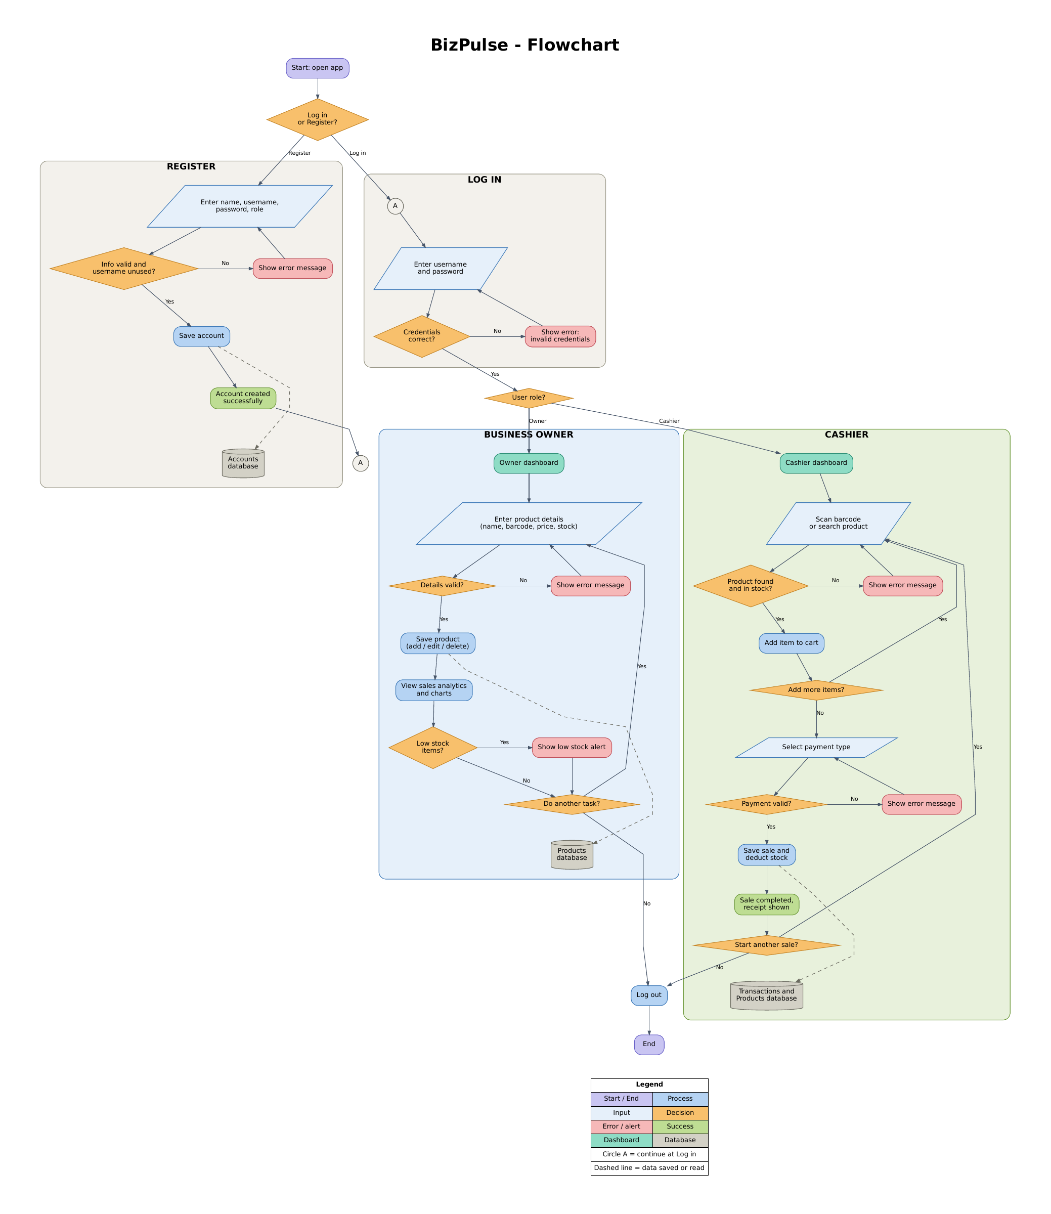

Application Flowchart Explanation
The flow begins when the user opens the application and chooses registration or login. Registration checks the entered details and whether the username is available. Login validates credentials before directing the user to an owner or cashier dashboard. Invalid input leads to an error message and another attempt.
The owner path covers product maintenance, analytics, and low-stock alerts. The cashier path covers product search or the intended scanning action, stock validation, cart entries, payment validation, and checkout. A successful sale deducts stock and displays a receipt. Users may continue working or log out.

Use Case Diagram
Figure 2. BizPulse Use Case Diagram
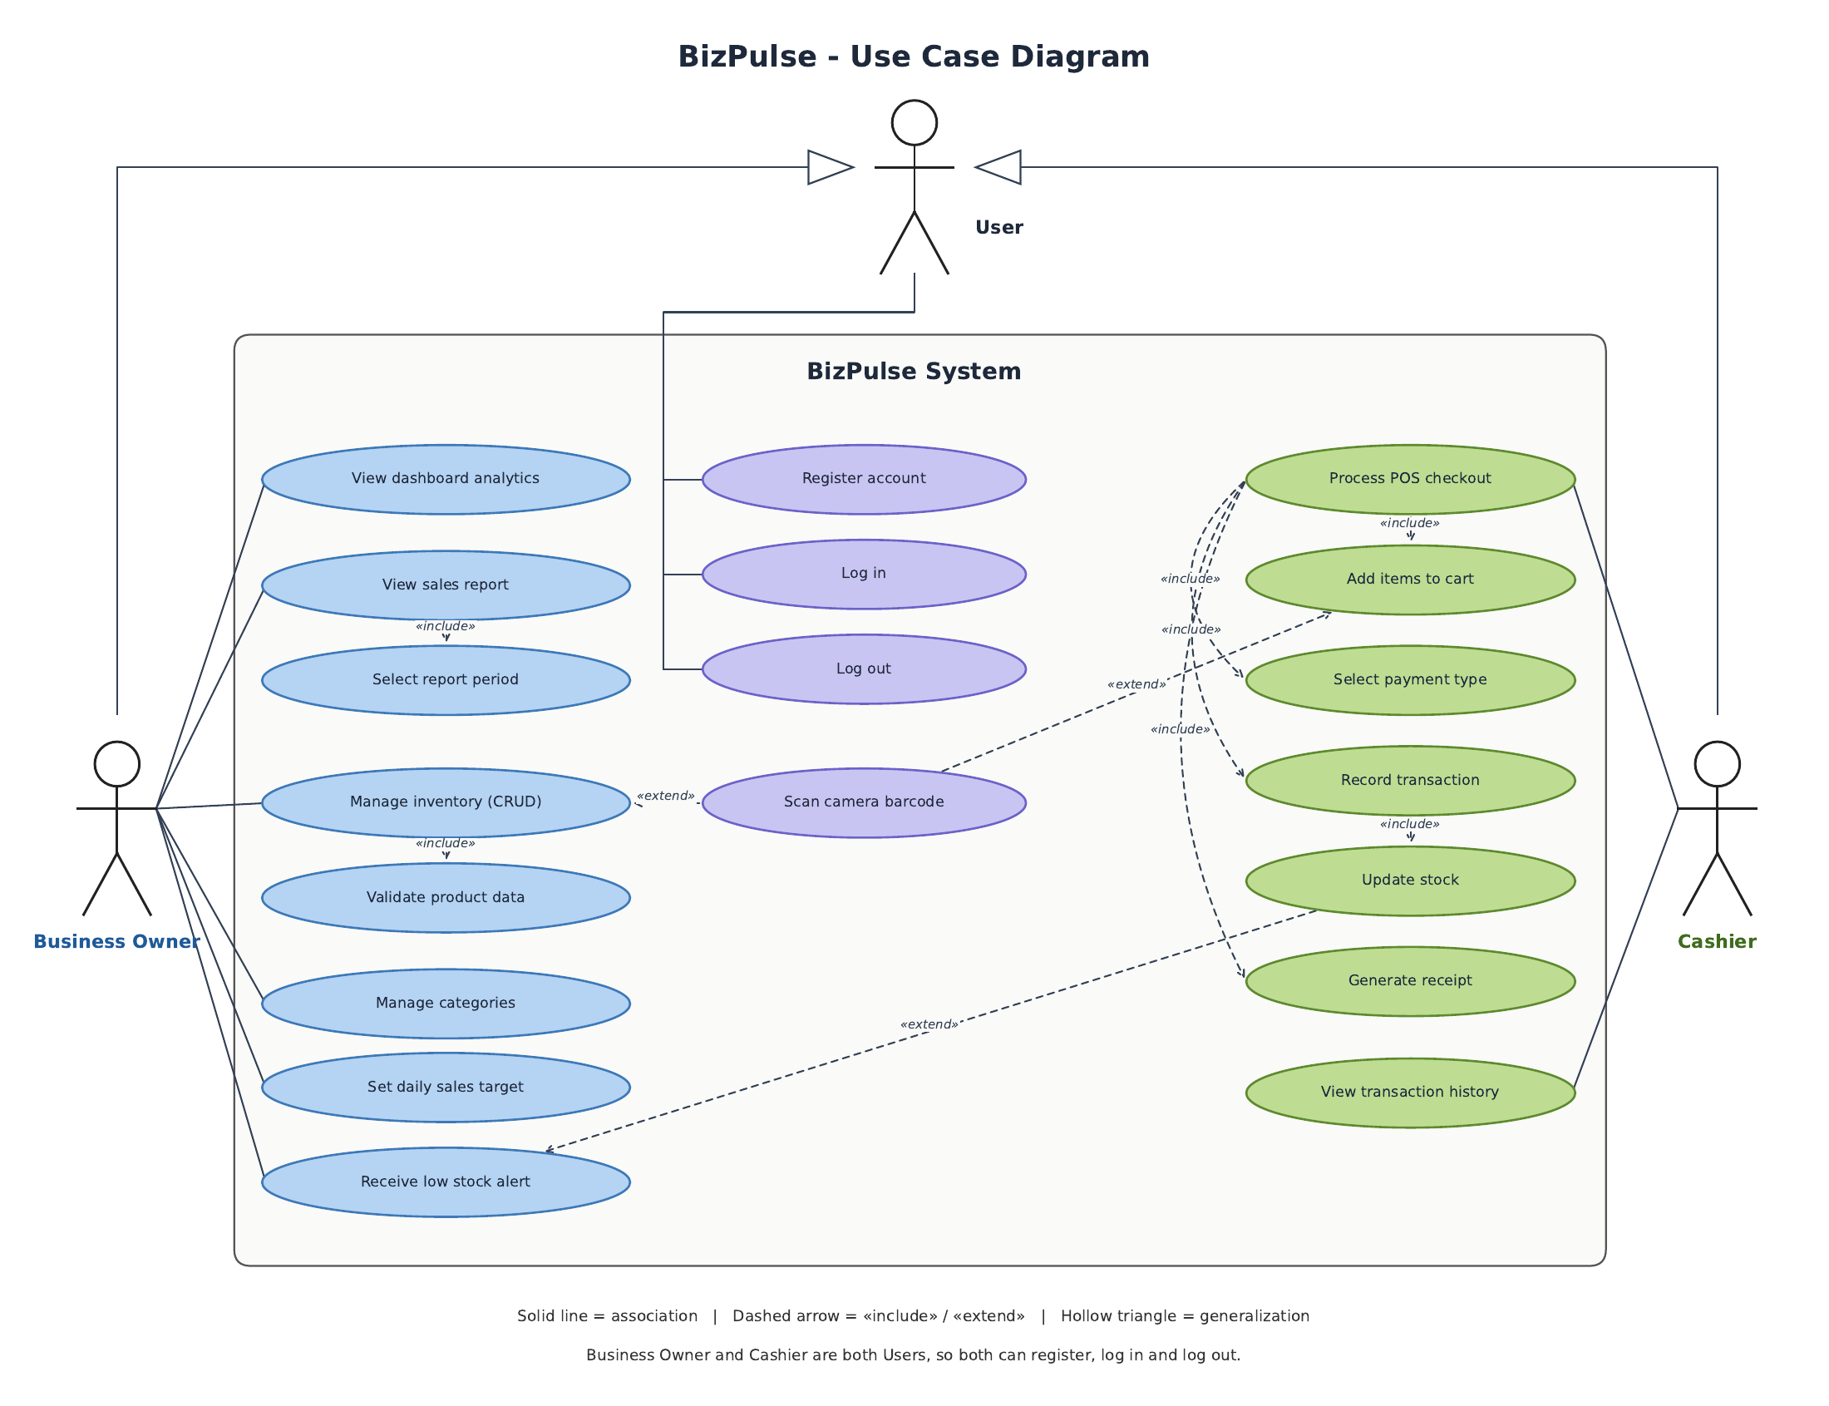
Both roles can view inventory and process sales. Owner-only actions are protected in repository methods as well as the interface. A cashier cannot gain modification rights simply by opening a hidden screen. The active owner cannot delete or demote their own account, and at least one owner must remain.

Database Design
Figure 3. Entity Relationship Diagram
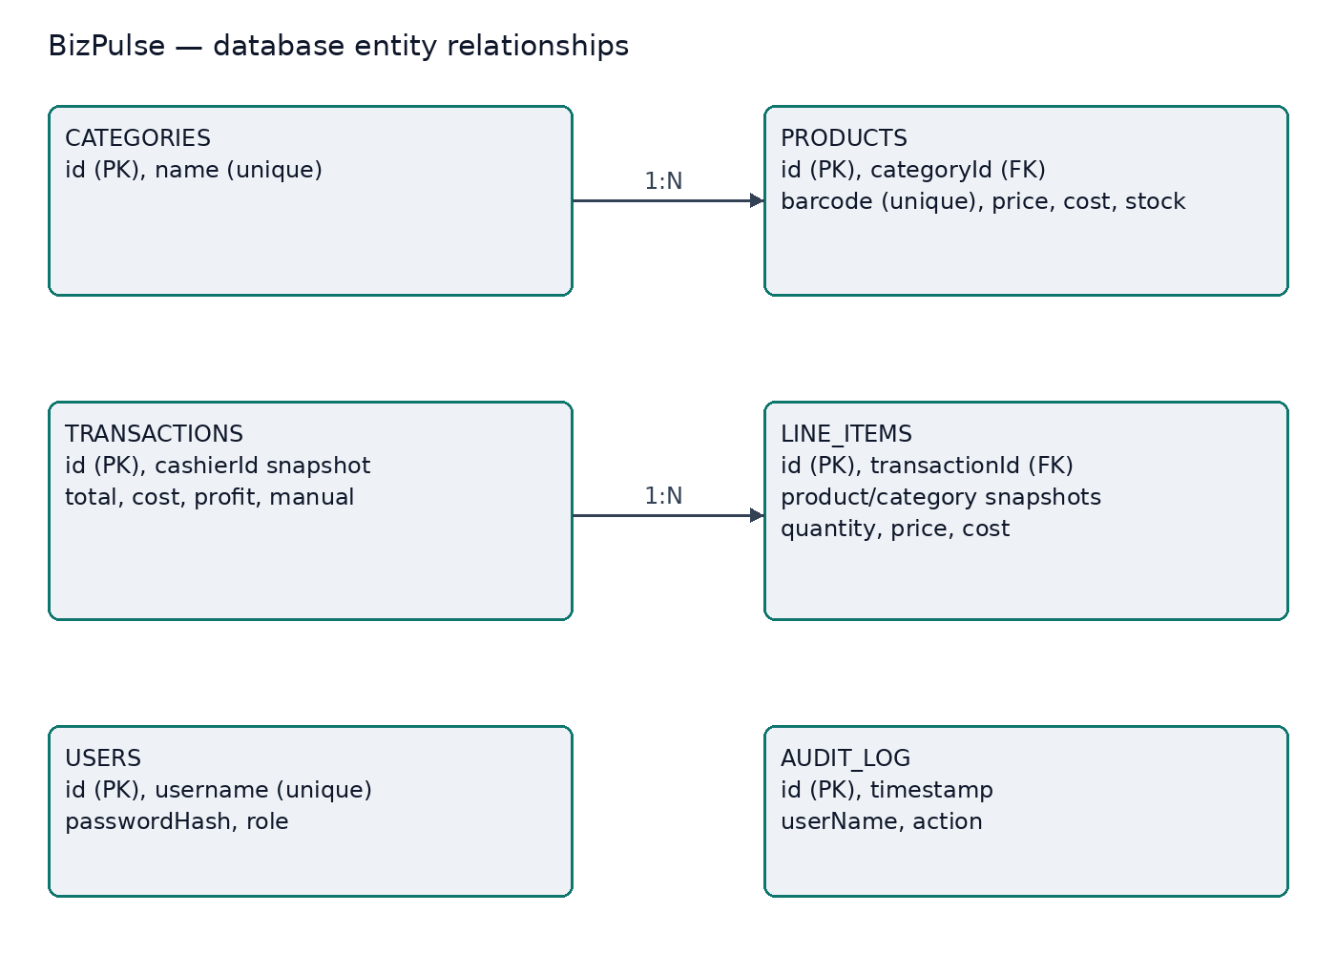
The explicit foreign keys are products.categoryId to categories.id, with deletion restricted, and lineItems.transactionId to transactions.id, with cascading line deletion. Other IDs and names on receipts are historical snapshots, allowing live records to change without destroying past sale details. Users and audit records have no direct foreign-key edge in this diagram.

IV. UI/UX and Implementation

UI/UX Design
BizPulse uses a consistent layout with readable labels, rounded cards, and role-based tabs. The dashboard emphasizes sales summaries and stock exceptions, while the POS screen combines product selection with cart details. Dark mode uses navy surfaces and light text. Confirmation prompts appear before reset, import, and delete actions.

A. Color Palette
Color | Hex code | Use
Emerald | #10B981 | Primary emphasis and actions
Slate | #0F172A | Contrast and dark surfaces
Light background | #EEF2F6 | Light-mode page background
White | #FFFFFF | Cards and contrast

B. Typography
The application uses the Compose theme with 24 sp and 20 sp headings, 14 sp body text, and 11 sp captions. Labels, spacing, and minimum 48 dp primary touch targets support readable and accessible interaction. Additional large-font and accessibility checks remain necessary.

C. Navigation Structure
After login, users enter the dashboard for their role. Main navigation includes Dashboard, Inventory, POS, Analytics, and Guide. Manage is available to owners. Cashiers can view inventory and process sales, while modification rights remain restricted.
The owner workflow proceeds from login to dashboard, inventory or management tasks, analytics review, and logout. The cashier workflow proceeds from login to dashboard, product search, cart review, payment, receipt display or printing, and logout.

D. Application Interface and Demonstration
The presentation demonstrates owner login, POS checkout, receipt display, analytics, and cashier restrictions. The supplied cart example shows a PHP 250 subtotal and PHP 30 VAT, producing a PHP 280 total. Receipt number 8 records the completed example sale. The screenshots in Appendix A show these interfaces and the supporting management screens.

Development Tools
Android Studio and the Android build toolchain support application development and APK compilation. GitHub stores the source code and submission materials. Actual manual testing was performed on a POCO X8 Pro running Android 16. The documented build uses JDK 17, Gradle 8.2, Android Gradle Plugin 8.2.2, and Android SDK 34.

Technologies Used
Technology | Use
Kotlin 1.9.22 / Compose | Application logic and declarative UI
Room 2.6.1 / SQLite | Persistent records and atomic operations
Hilt 2.50 / Coroutines | Dependency injection and background work
Navigation / DataStore | Screen routing and local preferences
ZXing Android Embedded 4.3.0 | Camera barcode scanning
JDK 17 / Gradle 8.2 / AGP 8.2.2 | Build toolchain; Android SDK 34

Feature Implementation
Compose screens display reactive state from ViewModels. Repositories validate data and enforce role permissions. Room persists six record types in SQLite, while DataStore maintains local preferences and session state. AppStore combines database streams for the interface.
Checkout rechecks stock and products before saving the transaction, receipt lines, stock deduction and audit event inside a Room transaction. Invalid payment or failed writes roll back the operation rather than leaving a partial sale.
Implementation records payment methods without an external gateway. Prices are before VAT; the demo applies 12% VAT at checkout. Displayed profit follows the supplied demonstration rule of collected revenue minus cost, rather than a certified accounting definition.
Role checks are applied in repository methods as well as in visible navigation. Backups are validated before an atomic restore, and malformed imports are rejected. Historical receipt lines retain snapshots so later changes to live products do not remove the original sale details.

V. Testing and Evaluation
Functional testing covers account access, inventory, checkout, receipts, permissions, offline use, backup and import, analytics, and data-management functions. Jedediah Ebalobo tested version 1 on a POCO X8 Pro with Android 16 on October 19, 2026. He confirmed the results on October 23, 2026: the 20 existing manual acceptance cases passed, and barcode scanning failed.
These are tester-reported manual results. Detailed measured outputs were not separately supplied for each case. The statuses below record the reported outcome without claiming an independent retest.

Manual Acceptance Results
Test case | Actual result | Status
1. Valid login | Worked as expected; no problem reported. | Pass
2. Invalid login | Worked as expected; no problem reported. | Pass
3. Weak registration | Worked as expected; no problem reported. | Pass
4. Add product | Worked as expected; no problem reported. | Pass
5. Edit product | Worked as expected; no problem reported. | Pass
6. Delete product | Worked as expected; no problem reported. | Pass
7. Out-of-stock cart | Worked as expected; no problem reported. | Pass
8. Insufficient cash | Worked as expected; no problem reported. | Pass
9. Complete sale | Worked as expected; no problem reported. | Pass
10. Quick Sale | Worked as expected; no problem reported. | Pass
11. Audit search | Worked as expected; no problem reported. | Pass
12. Export and import JSON | Worked as expected; no problem reported. | Pass
13. Cashier inventory | Worked as expected; no problem reported. | Pass
14. Cashier Manage | Worked as expected; no problem reported. | Pass
15. Offline operation | Worked as expected; no problem reported. | Pass
16. Print receipt | Worked as expected; no problem reported. | Pass
17. Reset data | Worked as expected; no problem reported. | Pass
18. Category analytics | Worked as expected; no problem reported. | Pass
19. Logout confirmation | Worked as expected; no problem reported. | Pass
20. Transaction deletion | Worked as expected; no problem reported. | Pass
21. Barcode scanning | Camera opened, but no barcode was recognized and no product was added. | Fail

Historical Build and Automated Checks
Check | Recorded result
JVM unit tests | 15 passed; zero failures and errors
Debug APK | Compilation passed
Android lint | Zero errors and seven warnings; partial Compose lint coverage
Instrumentation tests | Test APK compiled; device execution not recorded
Formal user evaluation | No completed responses supplied
The historical reports cover cart logic, currency formatting, password hashing, profit calculations, and validation. They were not rerun for this documentation revision. Manual test results apply to the reported device and scenarios; broader device and accessibility testing remains future work.

VI. Conclusion and Recommendations

Project Accomplishments
BizPulse brings inventory, sales, receipts, and business summaries together in a local Android application. The submitted demonstration shows cart calculation, successful checkout, receipt output, analytics, and management screens. The 20 reported passing acceptance cases support the tested workflow, while the barcode failure identifies a function requiring further work.

Problems Encountered
Challenge | Implementation response or current status
Stock and receipt accuracy | A Room transaction saves the sale, lines, stock, and audit record together; receipt lines retain historical snapshots.
Role restrictions | Repository methods enforce permissions even when a screen is hidden.
Malformed imports | Validate backups and restore atomically; reject invalid files.
Small-screen layouts | Use scrollable, inset-aware screens; further large-font testing is needed.
Barcode recognition | Camera opens but does not decode successfully; cause has not yet been identified.

Recommendations and Future Improvements
The first priority is to diagnose barcode decoding and product lookup, correct the implementation, and retest using a known product barcode. Further improvements include controlled owner enrollment, stronger password hashing, exact monetary storage, encrypted JSON backups, broader device and accessibility tests, formal user feedback, and production signing.

VII. Appendices

A. Actual Application Screenshots
The following screenshots show the running application on the POCO X8 Pro with Android 16 on October 19, 2026. They use dark mode. The cashier dashboard and analytics images were extracted from the demonstration video.

Major Application Screens
Figure 4. Login Screen and Owner Dashboard
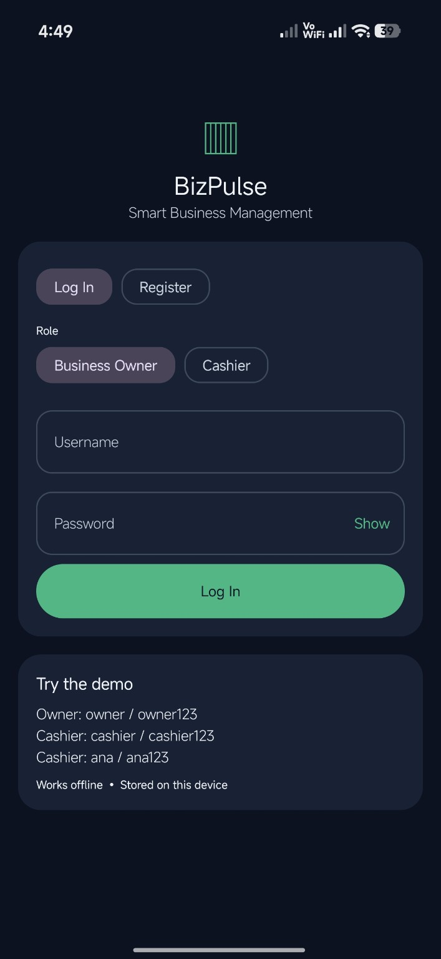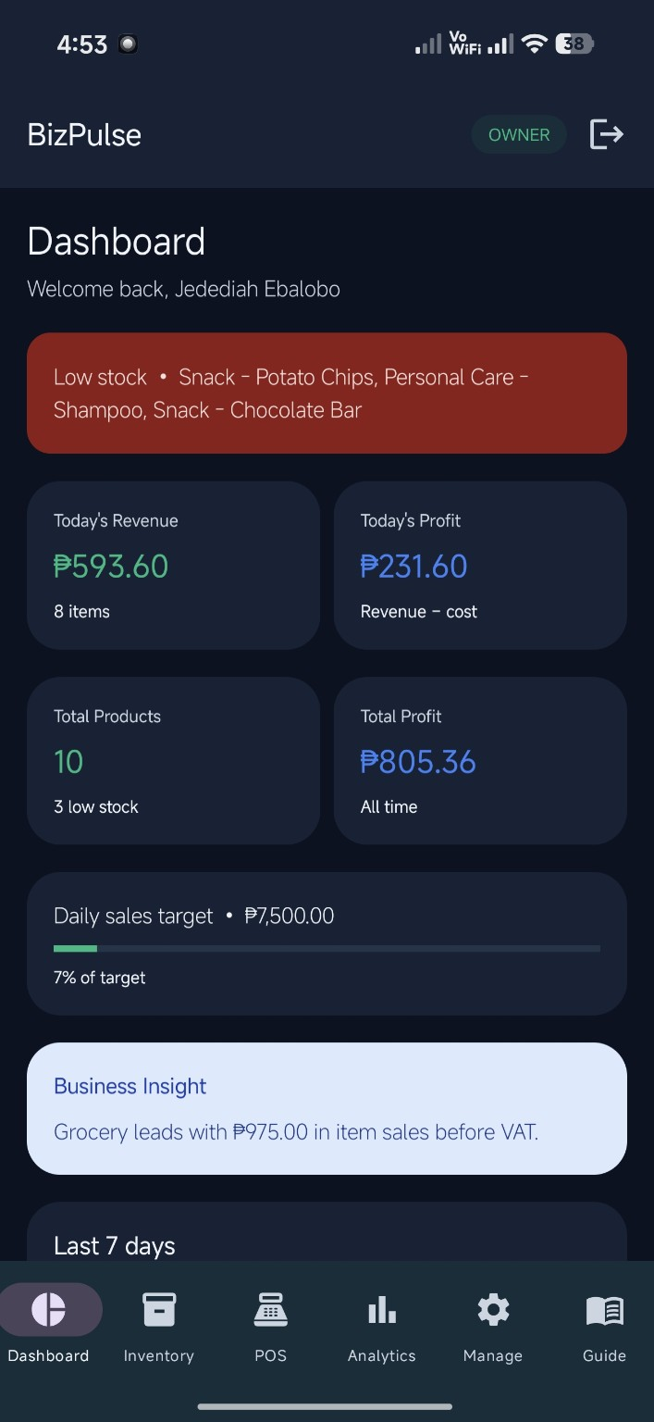
Left: Login Screen. Right: Owner Dashboard.

Actual Application Screenshots Continued
Figure 5. Cashier Dashboard and Inventory
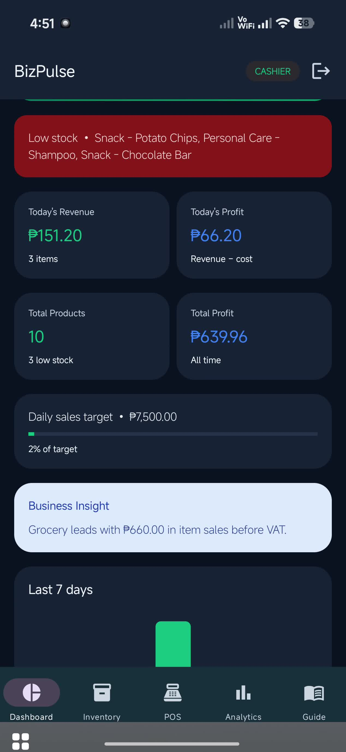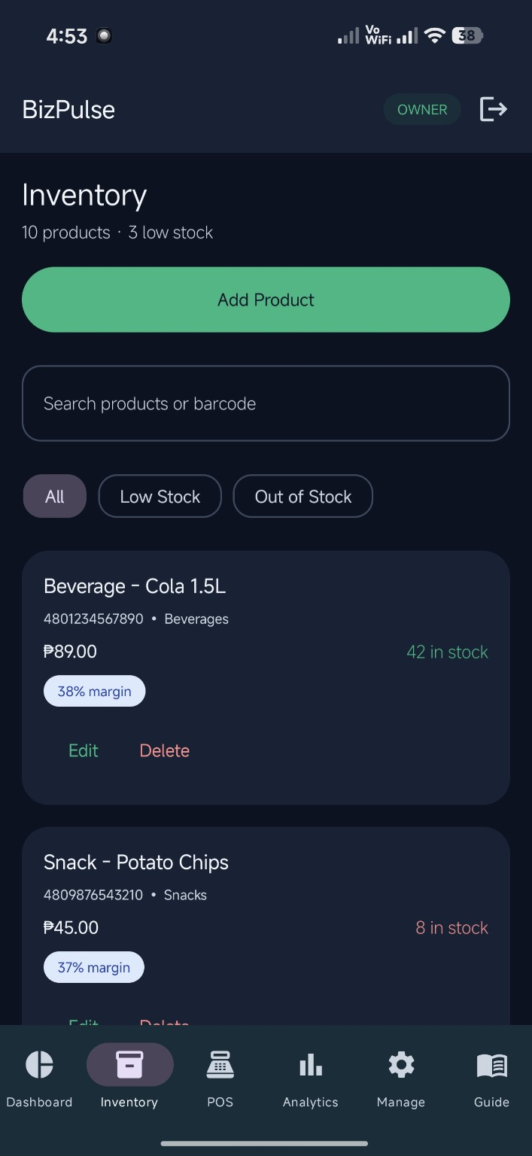
Left: Cashier Dashboard. Right: Inventory.

Actual Application Screenshots Continued
Figure 6. Product Form and POS Cart
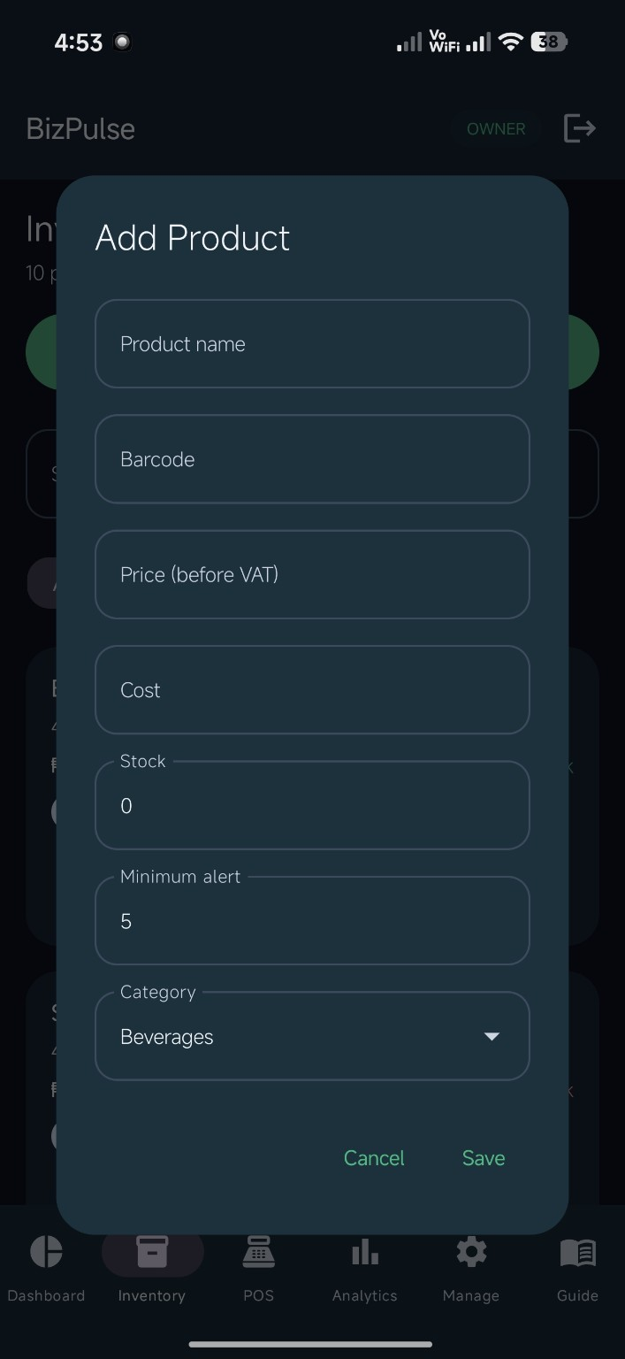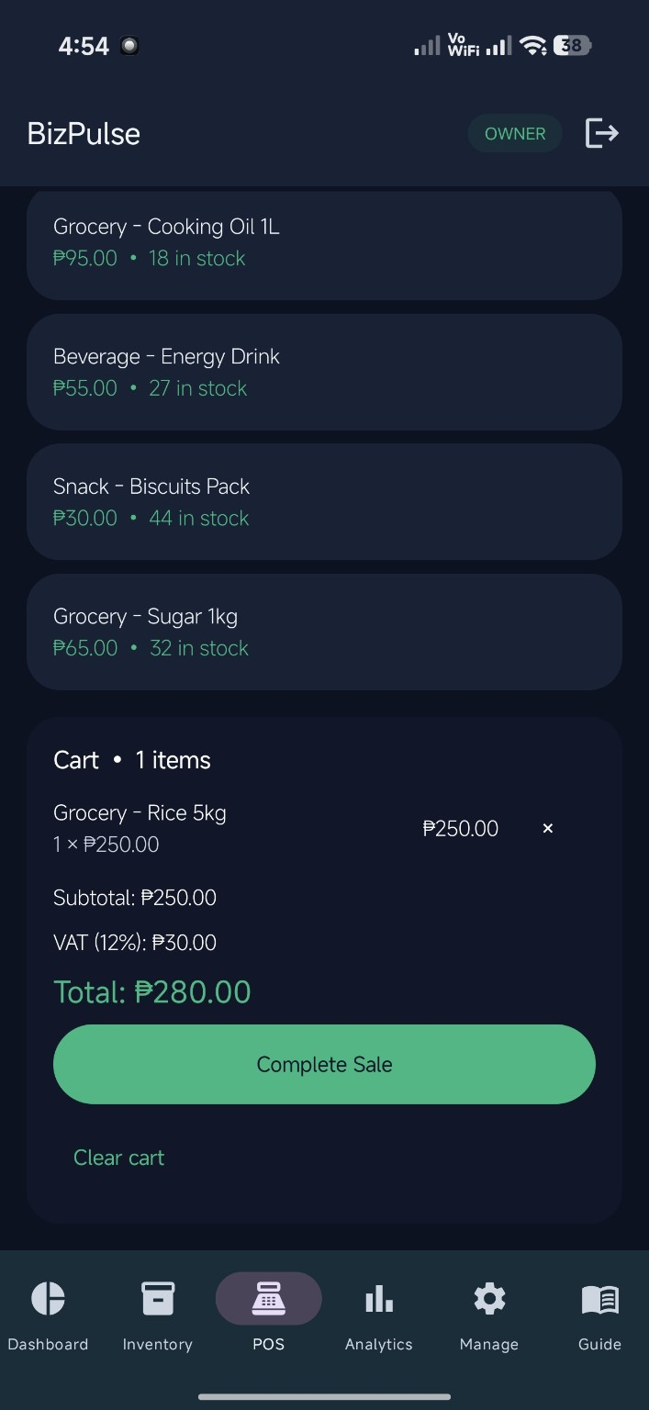
Left: Product Form. Right: POS Cart.

Actual Application Screenshots Continued
Figure 7. Receipt and Android Print Preview
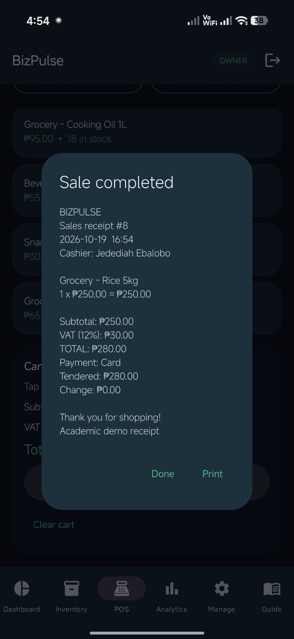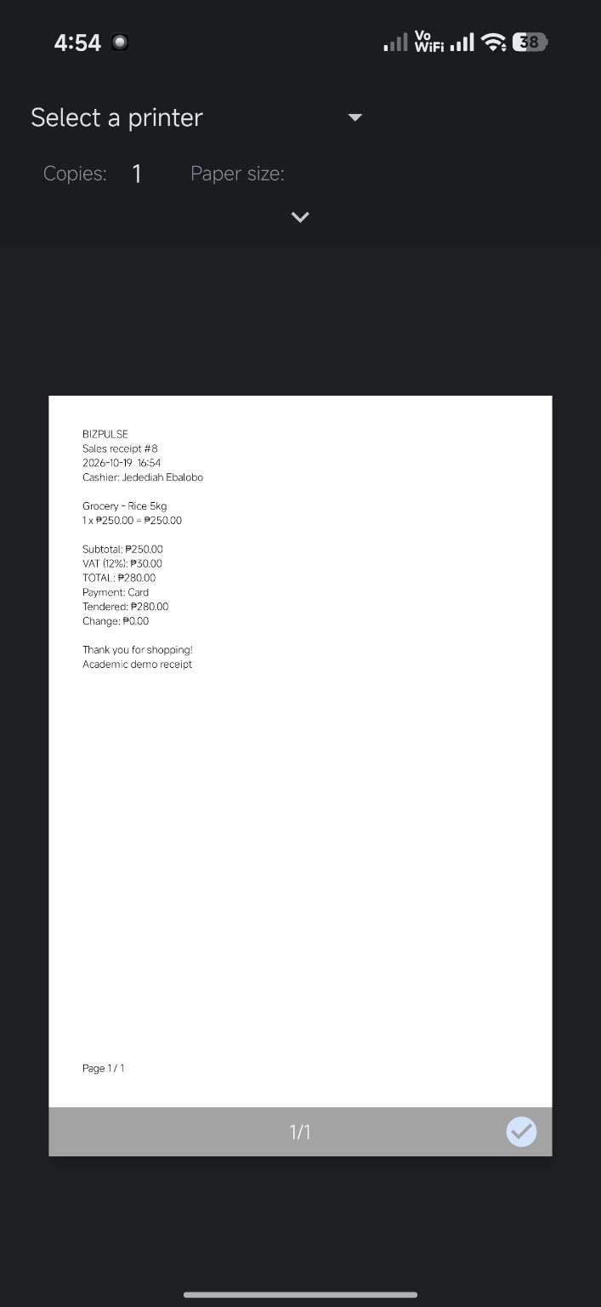
Left: Receipt. Right: Android Print Preview.

Actual Application Screenshots Continued
Figure 8. Analytics and Owner Management
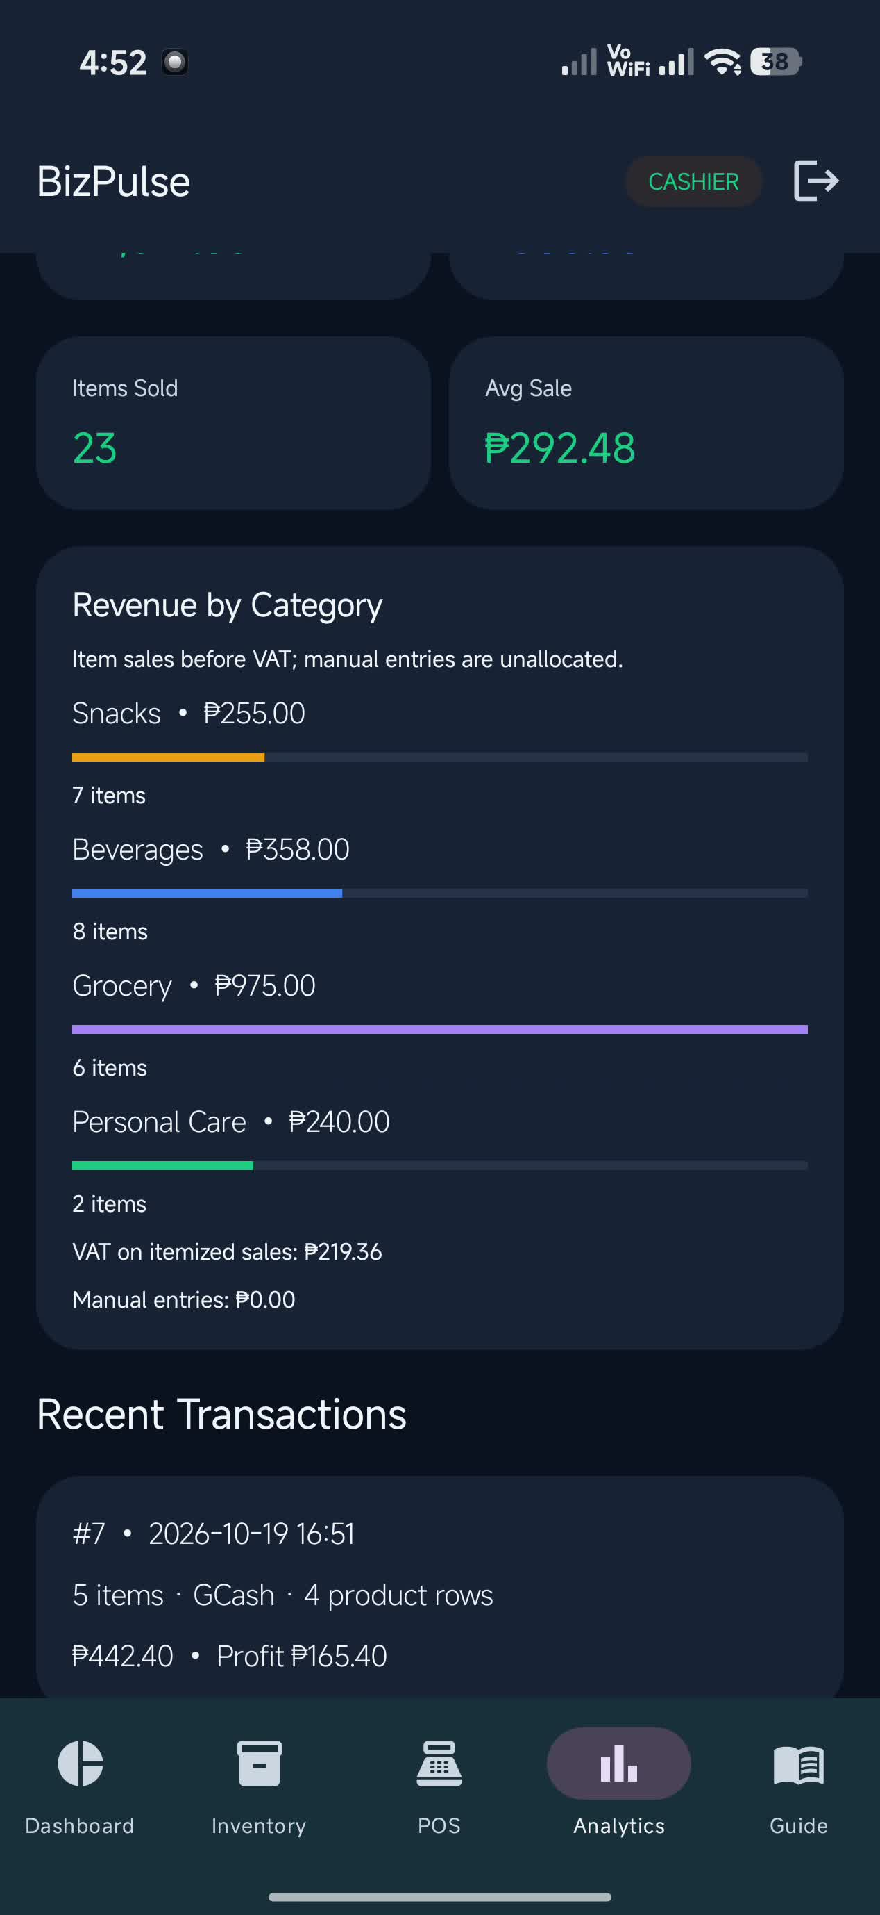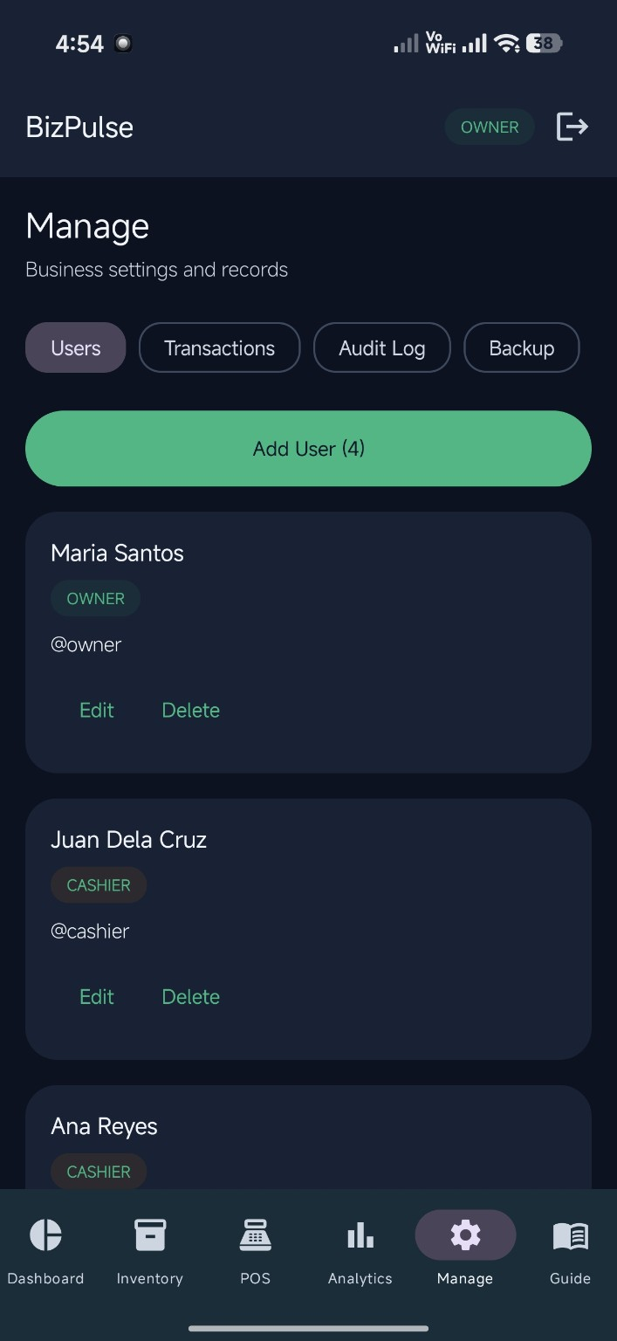
Left: Analytics. Right: Owner Management.

B. GitHub Repository and Supporting Materials
Repository: https://github.com/Jedfromanotherworld/BizPulse. The repository contains application source code and submission materials, including documentation, screenshots, testing records, and the APK.
The project presentation summarizes the problem, target users, major features, UI/UX, application demonstration, technologies, development challenges, testing results, and future improvements. The demonstration video provides additional evidence of selected app workflows. Password-entry sections are covered in the submitted video copy.
Development used AI assistance and third-party libraries. AndroidX, Kotlin/Coroutines, Dagger/Hilt, and ZXing retain their applicable licenses. Supporting license information is recorded in the project LICENSE and Documentation/THIRD-PARTY.md.

C. Team Contributions
Full name | Actual responsibilities / evidence
Jedediah Ebalobo | Programmer
Irene Trinidad | Assistant Programmer
Rochelyn Bacsal | Documentation
Ralph Jayrhard Amor | Researcher
Alexander Bacaran | Analyst

D. Instructor Evaluation
For the instructor or evaluator to complete.
Criteria | Maximum | Score
Functionality and Features | 25 | _____
UI/UX Design and Usability | 20 | _____
Technical Implementation | 20 | _____
Testing and Reliability | 10 | _____
GitHub and Source Code Management | 10 | _____
Documentation | 5 | _____
Presentation and Demonstration | 10 | _____
TOTAL | 100 | _____ / 100
Raw score: ______ / 100
Equivalent grade: ____________________
Overall comments:
________________________________________________
________________________________________________

Project Evaluation Decision
[ ] APPROVED
[ ] APPROVED WITH MINOR REVISIONS
[ ] FOR REVISION
[ ] NOT ACCEPTED
Required revisions:
1. ________________________________________________
2. ________________________________________________
3. ________________________________________________
Evaluated by: ______________________________________
Signature: _________________________________________
Date: _____________________________________________

